1. Create a table name STUDENT with following structure.

|  |  |  |  |
| --- | --- | --- | --- |
| # | Column | Description | Data Type |
| Name |
| 1 | RegNo | Registration | NUMBER(3) |
| Number |
| 2 | Name | Student Name | VARCHAR(15) |
| 3 | Gender | Gender of the | CHAR(1) |
| student |
| 4 | DOB | Date of Birth | DATE |
| 5 | MobileNo | Mobile Number | NUMBER(10) |
| 6 | City | Location of stay | VARCHAR(15) |

1. Create a table name FACULTY with following structure.

|  |  |  |  |
| --- | --- | --- | --- |
| # | Column | Description | Data Type |
| Name |
| 1 | FacNo | Faculty Identifier | VARCHAR(4) |
| 2 | FacName | Faculty Name | VARCHAR(15) |
| 3 | Gender | Gender of faculty | CHAR(1) |
| 4 | DOB | Date of Birth | DATE |
| 5 | DOJ | Date of Join | DATE |
| 6 | MobileNo | Mobile Number | NUMBER(10) |

1. Create a table name DEPARTMENT with following structure.

|  |  |  |  |
| --- | --- | --- | --- |
| # | Column | Description | Data Type |
| Name |
| 1 | DeptNo | Department Identifier | VARCHAR(4) |
| 2 | DeptName | Department Name | VARCHAR(15) |
| 3 | DeptHead | Department Head | VARCHAR(4) |

1. Create a table name COURSE with following structure.

|  |  |  |  |
| --- | --- | --- | --- |
| # | Column | Description | Data Type |
| Name |
| 1 | CourseNo | Course Identifier | VARCHAR(3) |
| 2 | CourseDesc | Course | VARCHAR(14) |
| Description |
| 3 | CourseType | Course Type | CHAR(1) |
| 4 | SemNo | Semester Number | CHAR(1) |
| 5 | HallNo | Hall Number | VARCHAR(4) |
| 6 | FacNo | Faculty Identifier | VARCHAR(4) |

1. Modify the table FACULTY by adding a column name DeptNo of datatype VARCHAR(4)

##### OUTPUTS:

1)

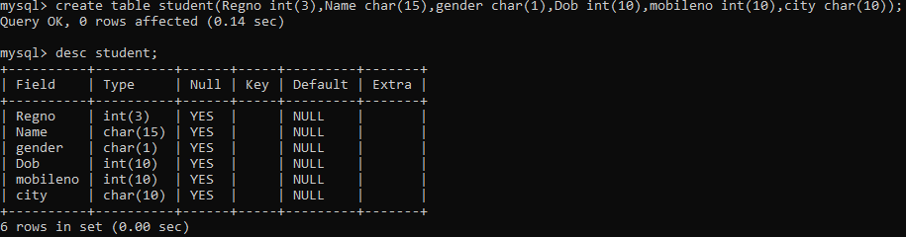

2)

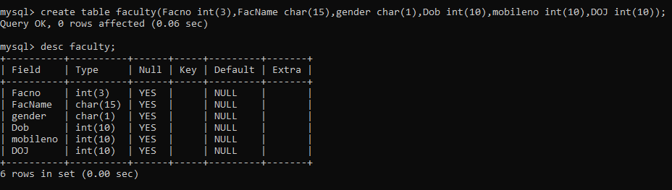

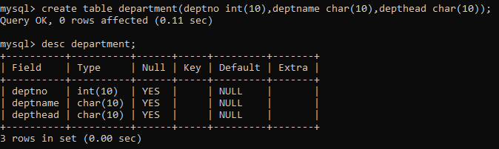3)

4)

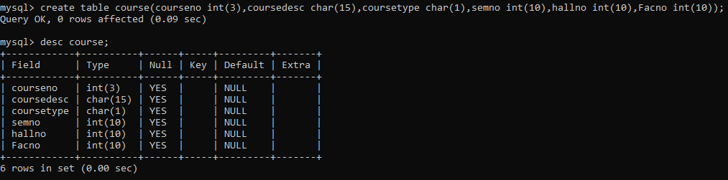

5)

